Supplementary material
      - A representative subroutine describing the rates of a mineral reaction in the Kinec_v3 database

Albite #NaAlSi3O8; M 262.219 g/mol
-start
1 name$ = "Albite"
2 if (PARM(1) = 0) then goto 3 else goto 5
3 if PARM(3) = 0 then S = PARM(2) * m * GFW(PHASE_FORMULA(name$)) else S = m0 * ((m/m0)^(2/3)) * GFW(PHASE_FORMULA(name$)) * PARM(2)
4 GOTO 100
5 S = PARM(2)*TOT("water")

##-----------------Dissolution and precipitation options--------------##
100 if (PARM(4) = 0) then goto 1000 else goto 110
110 if (PARM(4) = 1) Then GoTo 150 else goto 200
150 If (SR (name$) < 1) Then GoTo 5000 else GoTO 1000 # warning no dissolution reaction
200 If (SR (name$) > 1) Then GoTo 5000 else GoTO 1000 # warning no precipitation reaction

##------------------Kinetic calculation---------------------##
#Parameters
1000 Aa = 0.7 #mol.m-2.s-1
1001 An = 2.05e-1 #mol.m-2.s-1
1002 Ab = 1.5e-5 #mol.m-2.s-1
1003 Ea = 58000 #J.mol-1
1004 En = 60000 #J.mol-1
1005 Eb = 50000 #J.mol-1
1006 R = 8.314 #J.deg-1.mol-1
1008 na = 0.3
1010 nb = -0.3
1011 Sig = 3
#rate equations
2000 rplusa = Aa* (exp(-Ea/ (R * Tk)))*(act("H+")^na )* S
2001 rplusn = An* (exp(-En/ (R * Tk))) * S
2002 rplusb = Ab* (exp(-Eb/ (R * Tk)))* (act("H+")^nb) * S
2009 rplus = rplusa + rplusn + rplusb
3000 rate = rplus * (1 - (SR ("Albite")^(1/Sig)))
4000 moles = rate * time
5000 save moles
-end

      - A list of parameters required to run the Kinec_v3 database. The database uses these parameters to calculate the number of moles (referred to as moles in the database) dissolved or precipitated over the relevant timestep. See also section 6 of the main text.

Required Input Parameter | Variable name in database
Absolute temperature | Tk
Activity of the proton | Act(“H+”)
Activity of the aqueous bicarbonate | Act(“HCO3-”)
Activity of the aqueous carbonate | Act(“CO3-2”)
Duration of the reaction in seconds (e.g. duration of the timestep in the calculation). | Time
Gram formula weight of the mineral | GFW(“Mineral”)
Mass of the mineral in the system (g/kgw) | m0
Mass of water in the system (kg) | TOT(“water”)
Parameter describing the units for specific surface area | PARM(1)
Specific surface area of the mineral in units specified by PARM(1) | PARM(2)
Parameter describing how surface area changes with mineral mass | PARM(3)
Parameter allowing limiting reaction to either dissolution or precipitation | PARM(4)
Saturation Ratio of the mineral (equal to Q/K in equation 4) | SR(“Mineral”)

3 Examples of the use of the Kinec_v3 together with PHREEQC
3a. Dissolution of quartz sand
This example considers the dissolution of quartz sand in distilled water at 25° C and ambient pressure. Assuming the porosity of loosely compacted quartz sand is 40%, one kg of water (1000 cm³) will be contained within a bulk volume of 2500 cm³. The remaining 1500 cm³ corresponds to quartz. Taking account of the 22.688 cm³ mol⁻¹ molar volume of quartz (Helgeson et al., 1978), a total initial quartz mass of 66.15 moles is present for each kilogram of water. Assuming an sand grain diameter of 0.02 cm (200 microns), the geometric surface area of the sand $A_{geo}$, calculated using (Tester et al., 1994) :
$$A_{geo}=\frac{6}{ρ*d}$$

where $ρ$ stands for the density of quartz equal to 2.65 g cm⁻³ and d refers to the grain diameter. This yields a geometric surface area of 113.2 cm² g⁻¹. If the surface roughness of the quartz grains is 4, the BET surface area would be 452.8 cm² g⁻¹.
Taking these values into account, a PHREEQC input file to calculate the temporal evolution of the fluid phase in the system would be:

# ------------------------------------------------------------
# Quartz dissolution in distilled water at 25 °C
# Using Kinec_v3 rate equation for Quartz Dissolution https://github.com/Mou1a/Kinect_V3
# ------------------------------------------------------------

SOLUTION 1 Pure_water_25C
temp 25
pH 7 charge

KINETICS 1
Quartz
-m 66.15
-m0 66.15
-parms 0 0.045 1 2
-steps 5184000 in 60 steps # seconds
-cvode true

SELECTED_OUTPUT
-file quartz_output.txt
-time true
-pH true
-si Quartz
-totals Si

Explanation of the PHREEQC input file
- SOLUTION 1 Pure_water_at 25 °C
This command defines the initial aqueous solution as pure water at 25 °C. The keyword ‘charge’ indicates that the provided pH value of 7 is only an initial guess; PHREEQC will adjust this value as necessary to satisfy charge balance constraints.
- KINETICS 1 Quartz
Activates the kinetic rate equation for quartz defined in Kinec_v3.dat.
  - -m and -m 0 66.15 → These are the initial and current molal mass of quartz (calculated from the pore volume and quartz molar volume).
  - -parms 0 0.04528 1 2 → These four parameters are required for Kinec_v3 rate equations:
    - 0 → This parameter tells Kinec_v3 that the surface area is expressed in m² per gram of mineral.
    - 0.045 → This parameter tells Kinec_v3 the BET specific surface area of quartz in units of m²/g.
    - 1 → This parameter tells Kinec_v3 that the surface area decreases geometrically according to a shrinking sphere model as dissolution proceeds.
    - 2 → This parameter tells Kinec_v3 that dissolution only is allowed (precipitation not allowed).
  - -steps 5184000 in 60 steps → This tells the code to run the simulation for 5,184,000 seconds (~60 days) divided into 60 equal intervals.
  - -cvode true → activates the stiff CVODE solver for robust integration of the kinetic rate law.
- SELECTED_OUTPUT
Writes results to quartz_output.txt including:
  - simulation time,
  - solution pH,
  - saturation index of quartz,
  - total dissolved silicon.

A plot of the fluid composition over time generated using this input file is shown in Figure A1.
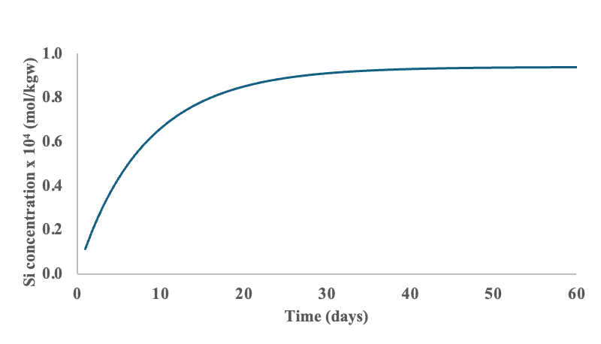
Figure A1. Temporal evolution of dissolved silicon concentration during the dissolution of quartz sand in distilled water at 25 °C, simulated with PHREEQC using the Kinec_v3 rate equations. Results correspond to an initial 66.15 mol of quartz per kilogram of water and a BET surface area of 0.04528 m² g⁻¹.

3b. Non-stoichiometric dissolution of an olivine solid solution at 120 °C in the presence of 20 atm CO₂ gas pressure
This example considers the dissolution of an olivine solid solution, Olivine_ss (Mg₁.₈Fe₀.₂SiO₄), at 120 °C in a reactor containing water in equilibrium with CO₂ at a fixed pressure of 20 atm. Olivine forms a solid-solution series between forsterite (Mg₂SiO₄) and fayalite (Fe₂SiO₄). The composition used here (Mg₁.₈Fe₀.₂SiO₄) is a typical Mg-rich (~10 mol% fayalite component).The system contains 1 kg of deionized water and 1 kg of olivine powder, corresponding to 6.79 mol of Olivine_ss.
Assuming an average grain diameter d = 50 µm (0.005 cm) and a density ρ = 3.32 g cm⁻³, the geometric specific surface area of the olivine is 0.0361 m² g⁻¹, and with a roughness factor of 4, the BET surface area of the olivine would be is 0.1446 m² g⁻¹.
In this example, hematite is allowed to precipitate at local equilibrium and magnesite, sepiolite and chalcedony are allowed to precipitate at rates calculated using the equations incorporated in Kinec_V3. The Kinec_V3 precipitation rate equations are based on the measured dissolution rates of the mineral assuming they can be extrapolated to precipitation using transition state theory (Hermanska et al., 2022, 2023; Oelkers and Addassi, 2025).
Taking these values into account, a PHREEQC input file to calculate the temporal evolution of the system and the results of this calculation are summarized in Figure A2.

# ------------------------------------------------------------
# Olivine_ss dissolution at 120 °C reacting with
# DI water equilibrated with 20 atm CO2; SSA = 0.1446 m2/g
# ------------------------------------------------------------

SOLUTION 1 DI water
temp 120
pH 6 charge
units mol/kgw

EQUILIBRIUM_PHASES 1
Hematite 0 0
CO2(g) 1.3 10

KINETICS 1
Olivine_ss
-formula Mg1.8Fe0.2SiO4 1
-m0 6.79 # 1 kg / 147.31 g/mol
-m 6.79
-parms 0 0.1446 1 2 # m2/g; SSA=0.1446; SA decline as shrinking sphere; dissolution only
-tol 1e-08

Magnesite
-m0 0.0001
-m 0.0001
-parms 0 10 1 0 # kinetic sink (precip/diss allowed)
-tol 1e-08

Chalcedony
-m0 0.0001
-m 0.0001
-parms 0 10 1 0 # kinetic sink (precip/diss allowed)
-tol 1e-08

Sepiolite
-m0 0.0001
-m 0.0001
-parms 0 10 1 0 # kinetic sink (precip/diss allowed)
-tol 1e-08

-steps 1 100 1000 3600 3600 3600 3600 3600 3600 3600 3600 3600 3600 36000 36000 36000 36000\
36000 36000 36000 36000 36000 36000 36000 36000 36000 36000 36000 36000 36000 36000\
36000 36000 36000 36000 36000 36000 36000 36000 36000 36000 36000 36000 36000 36000\
360000 360000 360000 360000 360000 360000 360000 360000 360000 360000 360000 360000 360000 360000
-cvode true

INCREMENTAL_REACTIONS true

SELECTED_OUTPUT 1
-file olivine_ss_output4.txt
-totals Mg Si Fe C
-equilibrium_phases Hematite CO2(g)
-saturation_indices Chalcedony Magnesite Sepiolite
-kinetic_reactants Chalcedony Magnesite Sepiolite Olivine_ss

Explanation of the PHREEQC input file
- SOLUTION 1 DI water
Deionized water at 120 °C. The keyword charge indicates that the provided pH value of 6 is an initial guess; PHREEQC adjusts this value as necessary to satisfy overall charge balance.
- EQUILIBRIUM_PHASES 1
Hematite is allowed to dissolve or precipitate at local equilibrium, providing a sink for the Fe liberated by olivine dissolution.
CO₃(g) is fixed to be in equilibrium with CO₂(g) having a pressure of 20 atm (log f CO₂, 1.3) throughout the calculation.
- KINETICS 1
Olivine_ss
Activates the rate equations for the olivine solid solution defined in Kinec_v3.dat.
- -formula Mg1.8Fe0.2SiO4
This is required because olivine is a solid solution and its composition is not predefined in the PHREEQC database; the chemical formula of all solid solutions in Kinec_v3 must be specified explicitly.
- m and -m0 6.79
This is the initial and current molar mass of olivine (corresponding to 1 kg of solid with a molar mass of 147.31 g mol⁻¹).
- -parms 0 0.1446 1 2
These four parameters are required for Kinec_v3 rate equations:
The first parameter, equal 0, indicates that the surface area of these minerals are expressed in m² per gram of mineral.
The second parameter, 0.1446, defines the BET specific surface area of the minerals in units of m²/g. This number is based on 50 µm grains with a roughness factor of 4.
The third parameter, 1, indicates that the olivine surface area decreases in accord with a shrinking sphere model as dissolution proceeds.
The fourth, 2, parameter indicates that only olivine dissolution is allowed (precipitation not allowed).
-tol 1e-08 → The numerical tolerance for solver stability.
Magnesite, Chalcedony, and Sepiolite
Activates the kinetic rate equations for the minerals Magnesite, Chalcedony and Sepiolite.
- m and -m0 0.0001
This value was set to be 1x10⁻⁴ for each of these minerals. A positive non-zero value of m and m0 are required for the surface area calculation. All rates in Kinec_v3 are proportional to the mineral-fluid interfacial surface area. If m and m0 are set to zero, the surface area in the calculation will be zero and no precipitation will occur.
-parms 0 10.0 1 0
These four parameters are required for Kinec_v3 rate equations:
The first parameter, 0, indicates that the surface area of these minerals are expressed in units of m² per gram of mineral.
The second parameter, 10.0, defines the BET specific surface area of the minerals in units of m²/g. This number is poorly constrained as the surface areas of precipitating minerals is largely unexplored, so this choice was largely arbitrary.
The third parameter, 1, indicates that the surface area of these minerals increase in accord with a shrinking sphere model as precipitation and/or dissolution proceeds.
The fourth parameter, 0, indicates that only the minerals are allowed to dissolve or precipitate.
-tol 1e-08 → The numerical tolerance for solver stability.
-steps
Defines the time points for output: early seconds (1–1000 s), ten 1-h intervals, then longer intervals for a total of ~75 days.
-cvode true
This activates the stiff CVODE solver for robust integration of the kinetic rate law.

- SELECTED_OUTPUT 1
Writes results to olivine_ss_output.txt, including:
- simulation time,
- solution pH,
- temperature,
- total concentrations of Mg, Si, Fe, and C,
- equilibrium status of Hematite and CO₂(g)
- saturation indices of Chalcedony, Sepiolite and Magnesite,
- kinetic reactants Magnesite, Chalcedony, Sepiolite and Olivine_ss.

A plot of the system evolution generated using this input is shown in the figure below.
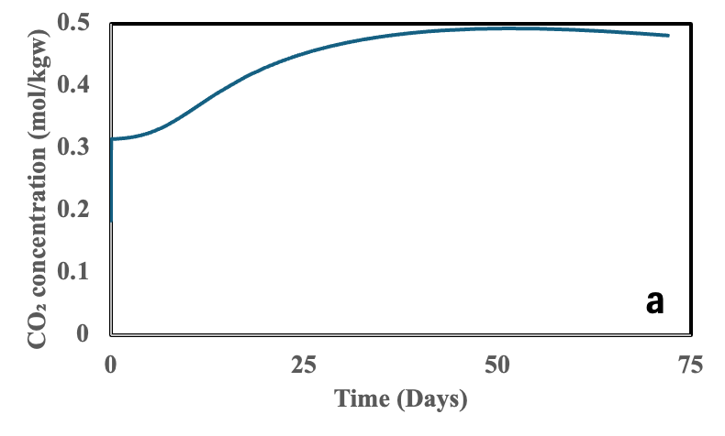 | 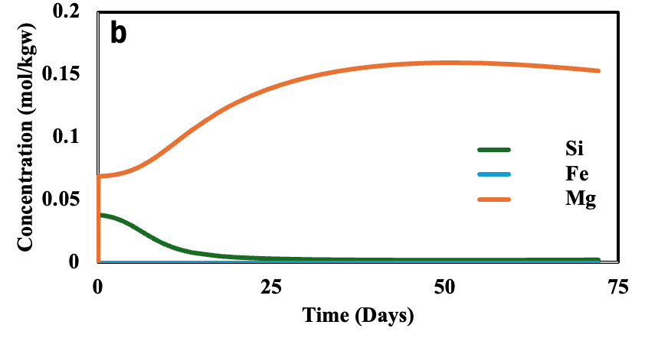
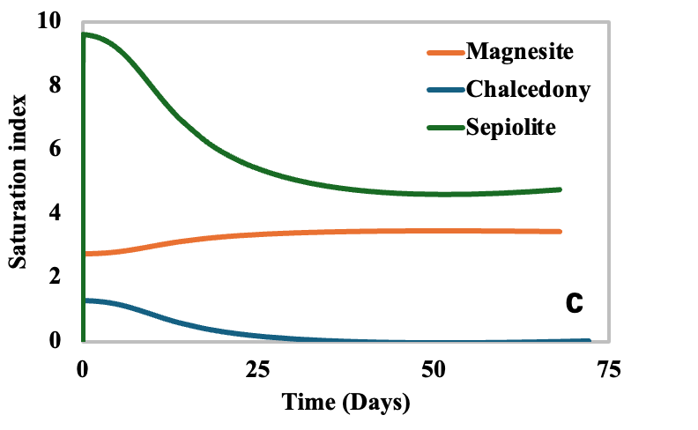 | 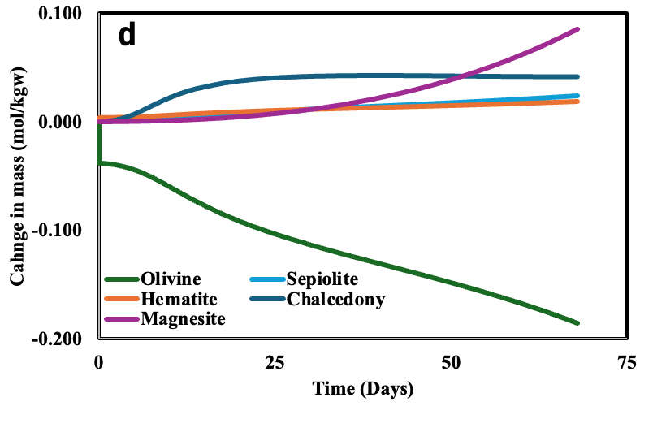
Figure A2. Temporal evolution of a system at 120 °C containing 1 kg of olivine and 1 kg of water in the presence of a constant 20 atm CO₂ pressure as described in the text: a) dissolved CO₂ concentration, b) dissolves Si, Fe and Mg concentration, c) the saturation indexes of magnesite, sepiolite, and chalcedony, and d) the total change in mass of the minerals during the calculation.

The calculated results shown in Figure A2, show the dissolved CO₂ concentration to increase over time. This reflects the increase in fluid pH as olivine dissolves into the fluid. The concentration of dissolved Si decreases after its initial increase due to the formation of sepiolite and chalcedony. The saturation indices of the secondary minerals, magnesite, chalcedony and sepiolite are significantly greater than zero as this is the driving force for the precipitation of these kinetically influenced reactions.

References
Helgeson, H.C., Delany, J.M., Nesbitt, H.W., Bird, D.K. (1978) Summary and critique of the thermodynamic properties of the rock forming minerals. Am. J. Sci., 278A, 1-119.
Heřmanská, M., Voigt, M.J., Marieni, C., Declercq, J., Oelkers, E.H., 2022. A comprehensive and internally consistent mineral dissolution rate database: Part I: Primary silicate minerals and glasses. Chemical Geology 597, 120807.
Heřmanská, M., Voigt, M.J., Marieni, C., Declercq, J., Oelkers, E.H., 2023. A comprehensive and internally consistent mineral dissolution rate database: Part II: Secondary silicate minerals. Chemical Geology 636, 121632.
Oelkers, E.H, Addassi, M. 2025. A comprehensive and consistent mineral dissolution rate database: Part III: Non-silicate minerals including carbonate, sulfate, phosphate, halide, and oxy-hydroxide minerals. Chemical Geology 636, 121632.
Tester, J.W., Worley, W.G., Robinson, B.A., Grigsby, C.O., Feerer, J.L., 1994. Correlating quartz dissolution kinetics in pure water from 25 to 625°C. Geochim. Cosmochim. Acta 58, 2407–2420.

